**WEB SCRAPING**

**WEBSITE:FLIPKART**

**PRODUCT:IPHONE 14**

**PYTHON CODE:**

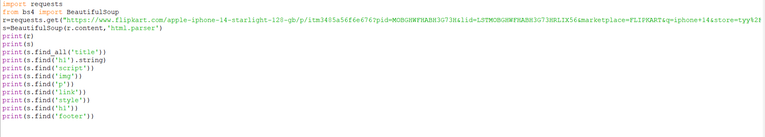

**TITLE:**



**<H1> TAG:**



**CONTENT:**

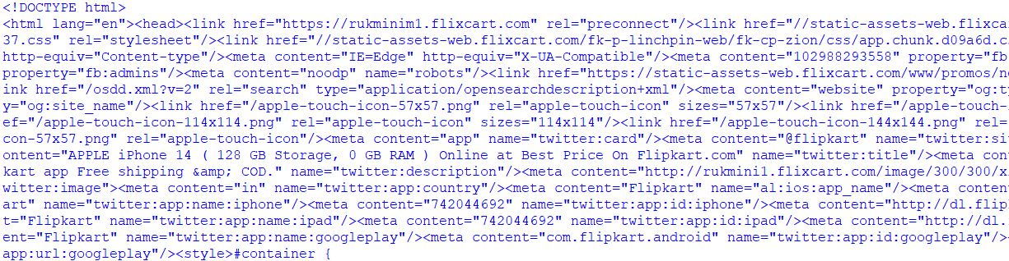

**PARAGRAPH TAG - <P>**

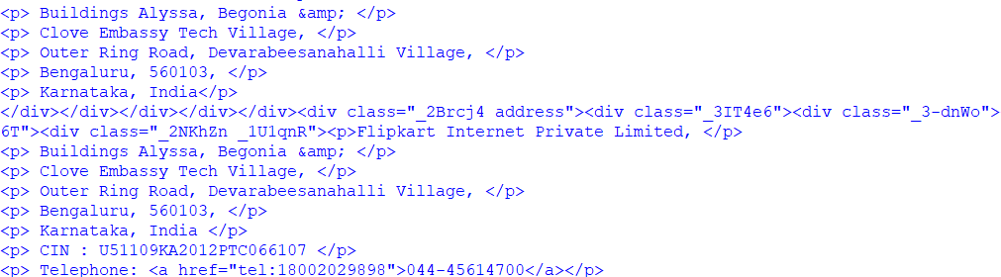

**STYLE:**

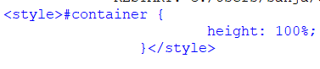

**SCRIPT:**



**IMAGE:**



**LINK:**



**FOOTER:**

